Name of Church

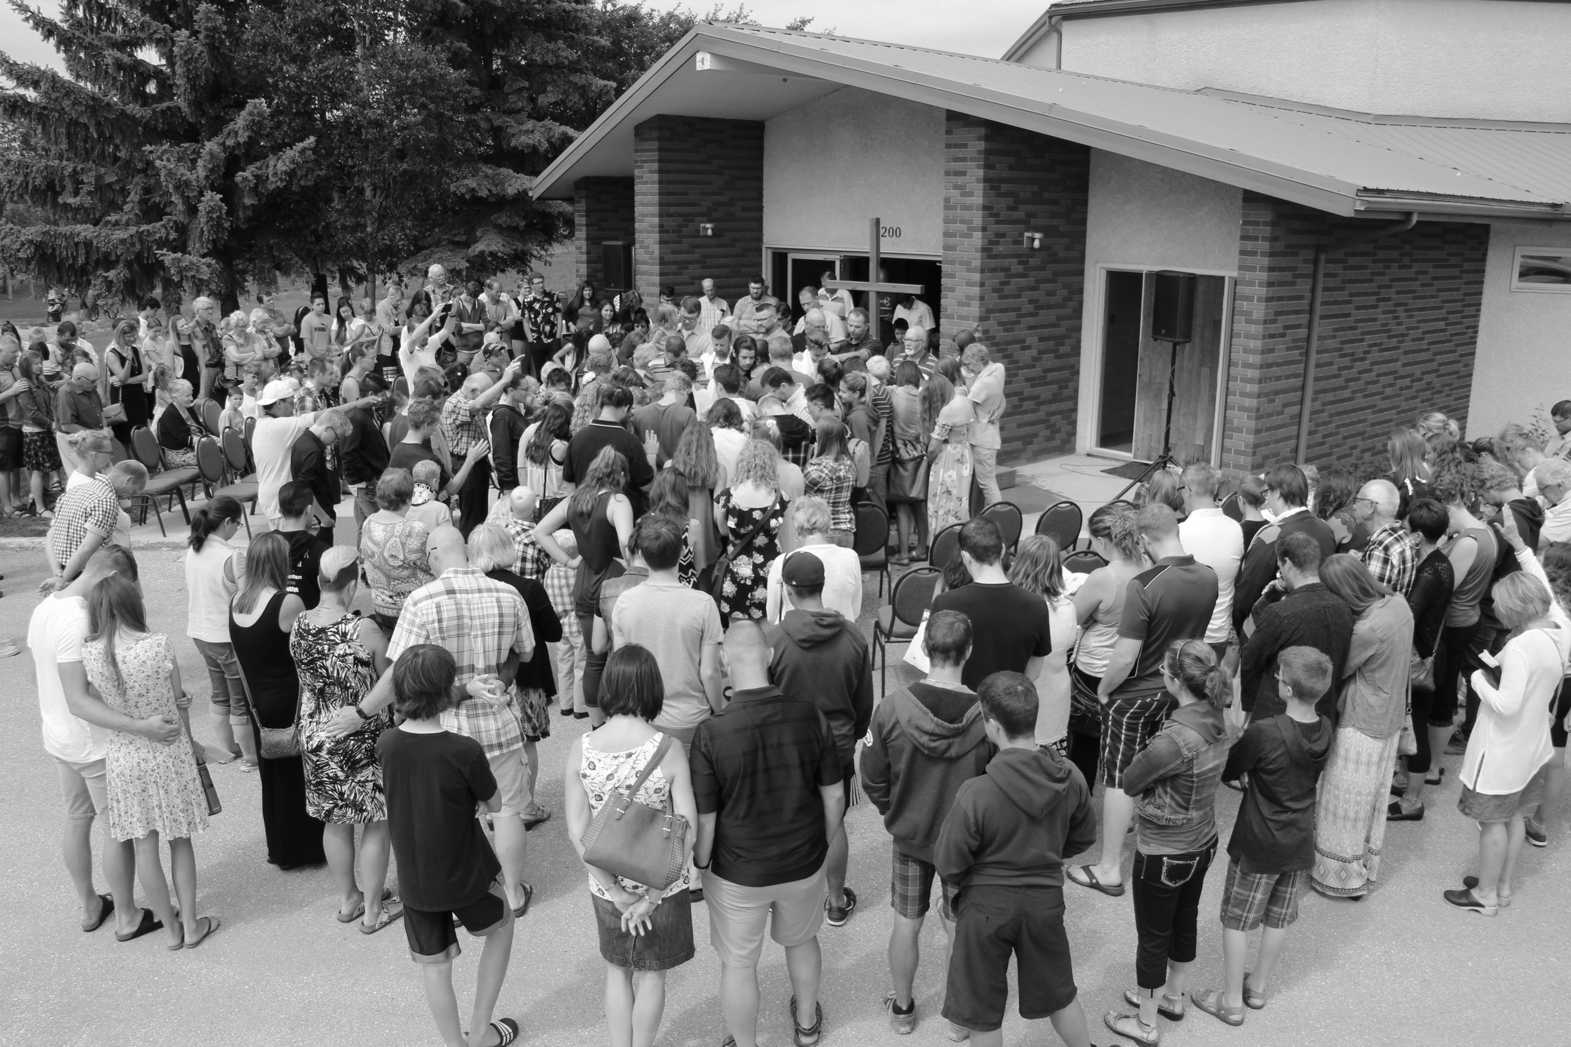
Photo: Brian Davis

Jesus Christ: Our Hope
Worship Together: Celebrate our Anabaptist Movement
Anabaptist World Fellowship Sunday



Date

